MAHARASHTRA STATE BOARD OF TECHNICAL EDUCATION MUMBAI

A

PROJECT REPORT ON

**“****Smart Electricity Energy Meter using Arduino for Smart City”**

UNDER THE GUIDANCE OF

**Mr.R.L.Kadam**



DEPARTMENT OF COMPUTER ENGINEERING

DR. D. Y. PATIL POLYTECHNIC,

KASABA BAWADA, KOLHAPUR

SEMESTER - VI

YEAR :- 2019-2020

SUBMITTED BY:-

1. Fiza Abdulgafoor Aga Enrollment no:1705390022
2. Atikraja Amanulla Khochikar Enrollment no: 1605390047
3. Shifa Nasir Khan Enrollment no:1705390023

**CERTIFICATE**

**This is to certify that**

1. **Fiza Abdugafoor Aga.**
2. **Atikraja Amanulla Khochikar.**
3. **Shifa Nasir Khan.**

**From Dr.D.Y.Patil Polytechnic (Code: 0539) institute having enrollment numbers: 170539002, 1605390047, 1705390023 respectively, have completed project of final year having title “ Smart Electricity Energy Meter using Arduino for Smart City” during the academic year of 2019-20. The project is completed in a group consisting of 3 persons under the guidance of the faculty Guide Mr.R.L.Kadam.**

**Name and Signature of Guide Name and Signature of HOD**

**Name and Signature of principal**

**ACKNOWLEDGMENT**

It is being a result of patients, hard work and mutual understanding; it is our great pleasure to represent this project on **“Smart Electricity Energy Meter using Arduino for Smart City”**

Everything needs some where to fallback upon sometimes. And we are not an exception. The completion of this project is the result of immense, heartfelt advice and suggestions from various people in various fields no matter how small they might seem to be.

We would first like to thank our guide **Mr. R.L.Kadam** without whom theproject completion of the project would have been a mere dream. Their suggestions, advice and wonderful ideas had never failed to add some color to this project.

Explicitly speaking, each and every teacher in Basic Science Department in Dr. D. Y. Patil Polytechnic aided in one way or another in turning this project into a reality. Thought it may not be possible to mention each one of them by name, we still like to thank them all for their aids.

The patience, advice and encouragement of our classmates and our friends in general had been too helpful to be neglected. Wondering what would happen without them. We heartily like to express our gratitude to them too.

Well charity can also last at home sometimes. We would also like to thank one another in our project group for this advice, hardworking patience and off course precious idea.

Date:

Place: Kolhapur.

**ABSTRACT**

An Energy meter is a electronic device that measures the total amount of electric energy mostly consumed by areas like commercial area, domestic. A smart energy meter (SEM) is electric device having energy meter chip for electric energy consumed measurement and for data communication using wireless protocol and peripheral devices for security purpose, data showing, meter controlling etc .It is clear that today’s emerging developments in every sectors with growing demands of electric power , so electricity has become high priority for each individual and also for organizations like a daily needs. The very basic procedure of power supply includes power generation, power transmission and power distribution to the various consumers and consumer may be corporate or domestic. Technically observed that naturally due to some technical faults, losses may occur. These losses can be resolve or minimized using the advanced technologies, but some losses unpredictable. These are the losses caused by human beings for their illegal access to the power distribution, and that we said the power theft. Proposed system, introduced method of post-paid electronic energy meter. This paper which will automatically sense the used energy, and continuously records the reading, then sends it for the billing to billing section through the Wi-Fi module. Finally, after processing the collected data bill is generated using a web based system software and is send back to the customer as SMS (Short Messaging System) using GSM network..

The project is proposed to save the efforts applied into manual Electric meter reading over millions of meters. The current approach in India for Electric meter reading is manual reading by taking digital photographs of the meter. These photographs are then collected together in Electricity Corporation to sort out corresponding to Wards and generate bills accordingly. These bills are printed and again distributed manually door to door. This makes difficult for the meter reader, data collector and billing person as well as bill distributor, therefore for the entire electricity corporation.

**Content Page**

|  |  |  |  |  |  |
| --- | --- | --- | --- | --- | --- |
| **Sr.No.** |  | **Content** | | | **Page no.** |
| **1.** |  | **INTRODUCTION** | | | **1-2** |
|  | 1.1 | Introduction | | | 1 |
|  | 1.2 | Problem Statement | | | 2 |
|  |  |  | | |  |
| **2.** |  | **LITERATURE OF SURVEY** | | | **3-5** |
|  | 2.1 | Automatic Meter Reading and Theft Control system by using GSM. | | | 3 |
|  | 2.2 | A Review paper n Automatic Meter Reading and Instant Billing | | | 3 |
|  | 2.3 | RF Based Automatic Energy Meter Reading system | | | 4 |
|  | 2.4 | Live Energy Meter and Billing System through GPRS. | | | 4 |
|  | 2.5 | GSM based Automatic Energy meter Reading System with Instant Billing. | | | 4. |
|  | 2.6 | Embedded energy meter | | | 5 |
|  |  |  | | |  |
| **3.** |  | **SCOPE OF THE PROJECT** | | | **6-8** |
|  | 3.1 | Scope of the project | | | 6 |
|  | 3.1 | Existing system | | | 6 |
|  | 3.3 | Proposed system | | | 8 |
|  |  |  | | |  |
| **4.** |  | **METHODLOGY** | | | **9-19`** |
|  | 4.1 | Major issues | | | 10 |
|  | 4.2 | Feasibility of the project and the estimation. | | | 11 |
|  | 4.3 | SRS | | | 12 |
|  |  | 4.3.1 | Purpose | | 12 |
|  |  | 4.3.2 | Definition, Acronyms, Abbreviations. | | 12 |
|  |  | 4.3.3 | Overview | | 13 |
|  |  | 4.3.3.1. | | The general description | 13 |
|  |  | * 1. Product perspective   2. Product functions | | |  |
|  |  | 4.3.3.2 | | Specific Requirements | 13 |
|  |  | 1.External Interface requirement | | |  |
|  | 4.4 | Requirements | | | 14 |
|  |  | 4.4.1 | Hardware | | 14 |
|  |  | 4.4.2 | Software | | 14 |
|  | 4.5 | Lifecycle model | | | 15 |
|  | 4.6 | Important Modules | | | 16 |
|  |  | 4.6.1 | Module 1 | | 16 |
|  |  | 4.6.2 | Module 2 | | 17 |
|  |  | 4.6.3 | Module 3 | | 17 |
|  | 4.7 | Implementation and coding | | | 17 |
|  |  | 4.7.1 | Technologies used | | 17 |
|  |  | 4.7.2 | Languages used | | 18 |
|  |  | 4.7.3 | Programming tools used | | 18 |
|  | 4.8 | Further work | | | 19 |
|  |  |  | | |  |
| **5.** |  | **DETAILS OF DESIGNS,WORKING AND PROCESSES** | | | **20-27** |
|  | 5.1 | Design | | | 20 |
|  |  | 5.1.1 | System architecture Design | | 20 |
|  | 5.2 | DFD | | | 21 |
|  |  | 5.2.1 | DFD Level 0 | | 21 |
|  |  | 5.2.2 | DFD Level 1 | | 21 |
|  | 5.3 | Sequence diagram | | | 23 |
|  | 5.4 | Circuit diagram | | | 23 |
|  | 5.5 | Source code | | | 24-27 |
|  |  |  | | |  |
| **6.** |  | **RESULTS AND APPLICATIONS** | | | **28-32** |
|  | 6.1 | Application | | | 28 |
|  | 6.2 | Results | | | 29 |
|  | 6.3 | Testing methods | | | 32 |
|  |  |  | | |  |
| **7.** |  | **CONCLUSIONS AND FUTURE SCOPE** | | | **35** |
|  | 7.1 | Conclusion | | |  |
|  | 7.2 | Future scope | | |  |
|  |  |  | | |  |
| **8.** |  | **REFERENCES AND BIBLOGRAPHY** | | | **36** |
|  | 8.1 | Websites | | |  |
|  | 8.2 | Reference paper | | |  |

**CHAPTER 1 : INRODUCTION**

**1.1 INTRODUCTION**

We never think the life without the electrical power because human survival and progress totally depends over it. The onset of electrification provides opportunities for new and more efficient metering technologies to be implemented and the future residential development needs. Previously used Power Line Communication [PLC] for data communication has many limitations like complexity of network, cost of installation and maintenance. For different type of service we require different frequency bands and power line uses 50 Hz also unable to support higher frequency bands. The power line is uncovered since losses also increases on the other hand interference between different channels is also big problem. There are some general problems like highly person dependent, human errors can’t be avoided, accessibility in rural zone, billing on monthly basis and its processing takes excess time. The Digital Tele watt meter System is an example of microprocessor-based meter. The meter was designed to transmit data on monthly basis to a remote central office through a dedicated telephone line and a pair of modems. Next was to use a DSP based meter to measure the electricity consumption of the customers in the residential area. So there is increased demand for Wireless Automatic Meter Reading (WAMR) systems which automatically collecting consumption, diagnostic, and status data from metering devices and transferring that data to a central database for billing, troubleshooting, and processing. It mainly reduces the human efforts as well as manual errors, provides real time correct consumption, Remote power switches on/off, which reduces required time and increases throughput. This paper presents an implementation methodology for a wireless automatic meter reading system (WAMRS) incorporating the widely used GSM/ GPRS network. In many countries GSM and GPRS network is widely known for its vast coverage area, cost effectiveness and also for its competitive ever-growing market. The system includes a microcontroller, which transmits the power consumption values periodically, via an existing GSM/GPRS network, to a master station. To maintain transparency between consumer and company we suggest a method where we utilize telecommunication systems for automated transmission of data to facilitate bill generation at the server end and also to the customer via SMS, Email. A new interactive, user friendly graphical user interface is developed using Microsoft visual studio .NET framework.

With proper authentication, users can access the developed web page details from anywhere in the world. In this paper, following a brief introduction of latest Automatic Meter Reading Systems described and summarized. The existing problems and future research directions are also discussion.

**1.2 PROBLEM STATEMENT**

The idea is proposed to save the efforts & labor applied into manual meter reading over millions of meters. The current approach in INDIA for meter reading is manual reading by taking digital photographs of the meter. This photograph is then collected together in Electricity Corporation to sort out corresponding to Wards, & make their bills. These bills are printed and again distributed manually door to door. This makes the job hectic to meter reader, data collector & billing person as well as bill distributor, therefore entire electricity corporation. As today Electricity Corporation has provided digital meters to every subscriber, we found the ultimate solution on effortless meter reading. An IOT based energy meter reading is internet based online meter reading system, which helps in taking meter reading anytime and from anywhere by using internet & web browser. This system eliminates the efforts of meter reading & bill distributor’s efforts and cost of Electricity Corporation over their workers. Additionally, in future paperless billing system can be implemented.

**CHAPTER 2- LITERATURE OF SURVEY**

* 1. **Automatic Meter Reading and Theft Control System by Using GSM *- P. Rakesh Malhotra et al. / International Journal of Engineering and Technology (IJET), Vol 5 No 2 Apr-May 2013, ISSN : 0975-4024***

**Idea used:** The project model reduces the manual manipulation work and theft .Use of GSM in our system provides the numerous advantages of wireless network systems. The government saves money by the control of theft in energy meter and also more beneficial for customer side and the government side. The metering IC ensure the accurate and reliable measurement of power consumed. Cost wise low when compared to other energy meter without

Automatic meter reading and theft control.

* 1. **A Review Paper on Automatic Meter Reading and Instant Billing - *International Journal of Advanced Research in Computer and Communication Engineering, Vol. 4, Issue 1, January 2015, ISSN (Online) : 2278-1021, ISSN (Print) : 2319-5940.***

**Idea used:** Data transmission is charged at standard SMS rates; thus the charges are not based on the duration of data transmission. The cost-efficient transmission of readings ensures that power consumption values can be transmitted more frequently to a remote station. The implications of being able to transmit readings more often are that energy utilities will be able to generate timely bills, better understand energy demand patterns, manage meter failures more efficiently and manage fraud better. The developed system is highly effective in the sense it is able to eliminate the drawback of serial communication. i.e. even though it lacks acknowledgement of the sent SMS it is not affecting system performance. If a message is missing then also as the system is accepting he cumulative value next time is which includes the lost content. And while preparing bill the system is accepting the maximum consumption value. These implementations make the designed system unique and effective compared to the previous proposals. Different state electricity boards in INDIA started using GSM facility for fault management and so there is increased demand for this method

* 1. **RF Based Automatic Energy Meter Reading System - *International Journal of Advanced Research in Computer Science and Software Engineering, Volume 4, Issue 9, September 2014, ISSN: 2277 128X.***

**Idea Used:** Automated meter reading systems have been implemented using many different technologies like GSM, ZigBee, PLC, D-SCADA, WiMAX and Hybrid Technologies that comprises of a mixture of the above. This survey paper describes the working models, strengths and weaknesses of each technology by considering various factors like feasibility, cost, reliability, efficiency and maintenance and user experience. This paper not only surveys the existing Automated Metering systems but also provides an abstract view of developing the most optimal automated meter reading system.

* 1. **Live Energy Meter Reading and Billing System through GPRS – *International Journal of Engineering Research & Technology (IJERT), Vol. 4 Issue 05, May-2015, ISSN: 2278-0181***

**Idea used:** The users can be aware of their electricity consumption. The human work of collecting readings by visiting every home at the end of every month can be avoided by generating Electricity bills automatically. Theft of electricity can be avoided by tamper proof energy meters. The errors in the system can be identified quickly.

**2.5 ‘GSM Based Automatic Energy Meter Reading System with Instant Billing’ IEEE 2013, Power System Technology and IEEE Power India Conference, 2013.**

**Idea used:** Method of postpaid electronic energy metering is introduced in this paper which will automatically sense the used energy, records these reading continuously, then sends it to the billing point through the existing GSM network. A GSM based wireless communication module is integrated with electronic energy meter of each entity to have remote access over the usage of electricity. Finally after processing the collected data bill is generated using a web-based system software and is send back to the customer as SMS (Short Messaging System).As it is web oriented once the data is updated, the registered users and authority can monitor and analyses the generated bill of any month by sitting anywhere in the world.

**2.6** **“Embedded Energy Meter- A new concept to measure the energy consumed by a consumer and to pay the bill”, Power System Technology and IEEE Power India Conference, 2008.**

**Idea used**: In this paper, a new concept of energy meter will be discussed, where maximum demand of energy of a consumer will be indicated in the meter used by the consumer. After exceeding the maximum demand, the meter and hence the connection will automatically be disconnected by an embedded system inserted in the meter itself. According to the maximum demand, the consumer will purchase a cash-card of amount depending on the consumption of energy and after the full consumption, the consumer again has to purchase another cash-card or recharge the same and thus the hassle related to go to the billing office, to stand in a long queue and to submit the bill, can be avoided. Also this system helps to eliminate the draw backs of billing management system, such as to take the reading from the meter, to create the bill, to print the bill, to send the bill to the proper address and to collect the amount for the bill.

**CHAPTER 3- SCOPE OF PROJECT**

**3.1 SCOPE OF THE PROJECT**

**Prepaid Electricity Energy Meter** is a good concept in which you can recharge its balance, like we do in our mobile phones. In this project we are building an automated system by **using Arduino and GSM module**. You can recharge the electricity balance through this system, just by sending a SMS. It can also disconnect the home power supply connection, if there is low or zero balance in the system. And this system will **reads the energy meter readings** **and automatically send some updates** to user’s mobile phone like low balance alert, cut off alert, resume alert and recharge alert  When we power up the system then it reads previous values of rupees stored in EEPROM and restores them into the variables then checks the available balance with the predefined value and take action according to them, like if available balance is greater than 15 rupees then Arduino turns On the electricity of home or office by using relay. And if balance is less than 15 rupees then Arduino sends a SMS to user phone regarding low balance alert and requesting to recharge soon. And if balance is less than 5 rupees then Arduino turns Off the electricity connection of home and sends a SMS to user’s phone for ‘Light Cut’ alert and requesting to recharge soon. GSM module has been used to send and receive messages, you can check about [GSM module and AT commands here](http://circuitdigest.com/microcontroller-projects/wireless-notice-board-using-gsm-and-arduino#gsm_module). Now when we need to recharge our system, we can recharge it simply by sending a SMS to the system, through our Cellphone. Like if we want to recharge by 45 bucks then we will send #45*, here # and * are prefix and suffix to the recharge amount. System receives this message and extract recharge amount and update the balance of system. And system again turns on the electricity of the house or office. This flow of working can be understood through the video at the end.

**3.2 EXISTING SYSTEM**

The existing systems are either an electronic energy meter or an electro-mechanical meter which are currently in use is limited to record up to kWh units. The kWh units recorded by meter readers monthly, on foot which need to be processed by a meter reading company. For processing the meter reading, company needs to link each recorded usage data to the particular account holder and then determine the amount owed by means of the specific tariff in use. On basis of various platforms researchers proposed many systems for Automatic Meter Reading (AMR). There are various wire-based AMR systems like Power Line Carrier (PLC) and Telephone Line Network (optical/ cable) and wireless AMR systems such as E-metering systems based on GPRS, Bluetooth, GSM. Design of an Electric Energy Meter for long-distance data information transfers which based upon GPRS, but this system can’t be implemented so easily because the regular use of GPRS is still a dream to the common man. A GSM based Energy meter with instant billing facility is introduced is efficient, but still the problem of missing SMS will degrade the accuracy and performance. A more reliable and user-friendly system by creating web portal for multiple access using the advanced Visual studio .net frame work which will manage the data efficiently even if there is loss of SMS. It makes the design different from the previous proposals and also increases the throughput. The GSM/GPRS channel is a very useful means of communication as sending data as SMS turns out to be a very handy tool, due to its good area coverage capability and cost effectiveness. The front-end web portal is User friendly and any employee with minimum knowledge of computers can work on this software. Employees can read the meter by sitting in their office

**3.3 PROPOSED SYSTEM**

In proposed idea, the energy meter is connected to the internet to make it online and securely accessible throughout the world with help of microcontroller. The AVR ATMEGA -328 MCU is used to control the entire system. The program is written in embedded language for AVR ATMEGA – 328 MCU based on Open Source Arduino structure. GSM / GPRS modem is used to access the GPRS (General Packet Radio Service) internet. The energy meter consists of a blinking LED as Unit indicator which generally blinks 3200 times for 1 unit of energy consumption. We are proposing the system to take the reading of energy meter i.e. electricity consumption with help of current sensor. To get reading of the total electricity consumption, we are sensing the current thru current sensor. The current sensor gives signal to the MCU. The MCU takes the reading of sensor and uploads to the custom created webpage by using GPRS service. MCU keeps continuous update on this online web portal. The circuit breaker is used to cutoff the owner’s supply on the input from web portal indicating the prepaid balance getting low and an alert SMS will be sent to the owner. Whenever user gets an SMS, he is supposed to pay the prepaid amount of electricity. He can pay from the web portal with his authenticated account on web page. Once user makes payment, corresponding units of electricity will be added to users account and the value of this unit will be sent to the meter logger. Once meter logger receive the value, it automatically disables the circuit breaker and continues the electricity supply. This will be a one step ahead in paperless digital billing system.

**CHAPTER 4-**

**METHODOLOGY**

The following hardware components are used in this project for the specific purposes. Details are listed below.

1. **Circuit breaker (Relay)**

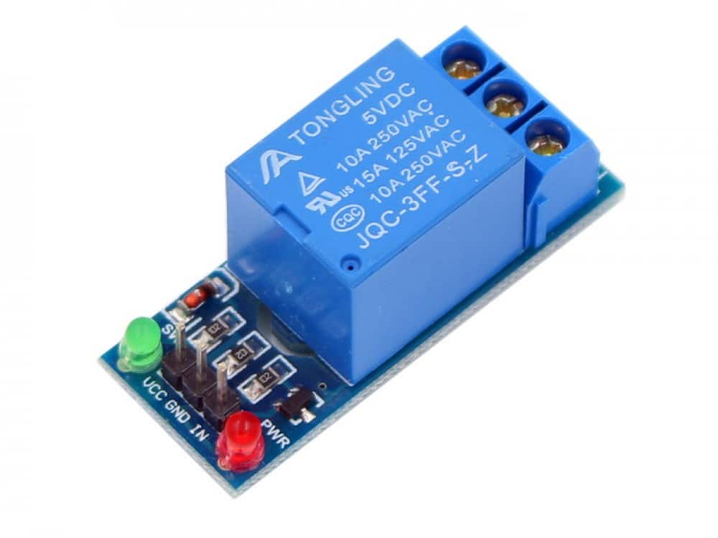

A relay is an electrically operated switch. In this system when number of units are totally consumed the electricity is cut off. This function is carried out by the relay. The microcontroller gives signal to relay, then it disconnects the further power supply.

1. **GSM modem**

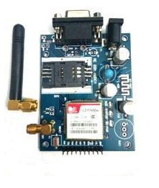

GSM modem is connected to a computer which allows the computer to use the GSM modem to communicate over the mobile network. While these GSM modems are most frequently used to provide mobile internet connectivity, many of them can also be used for sending and receiving SMS. When consumption reaches up to 90% of the total usage, a SMS will be sent to the user.

1. **Current Sensor**.

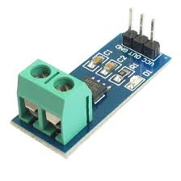

It detects electric current in a wire and generates a signal proportional to that current. The generated signal is taken as input through Arduino. It is used to sense current and display the consumed units by the meter.

1. **SMPS**

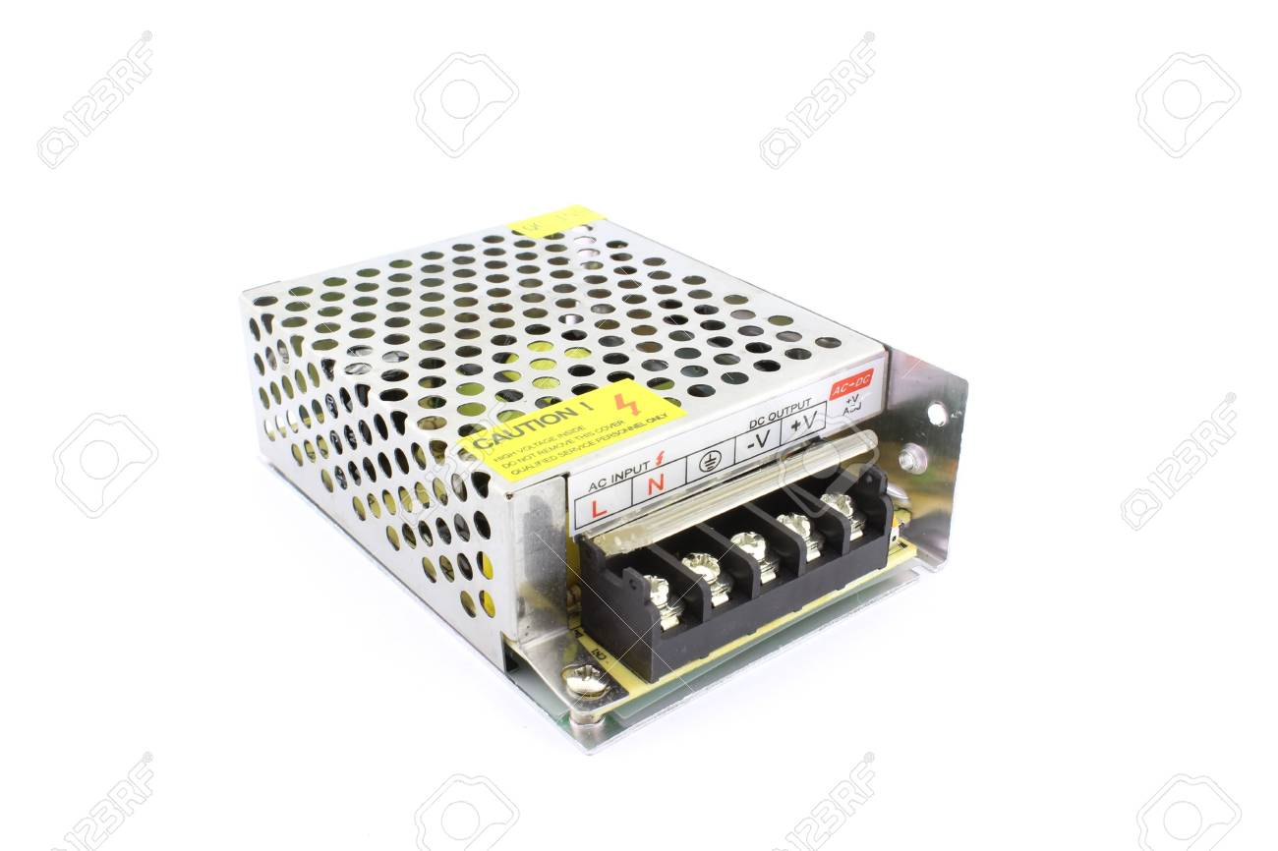

**4.1 Major issues:**

The method of meter reading is inefficient, because the readings are collected manually. This requires huge manual power. This collected data is recorded on a piece of paper along with a snap shot of the meter and finally submitted to the local electricity corporation. This system may consist of manual errors. Hence, we have come up with prepaid energy meter reading and billing system. To implement prepaid system, we introduced a circuit breaker which will be used to cut off the electricity supply when balance is over. The webpage is created to display consumption value and all the details of the user.

**4.2 Feasibility of the project and estimation:**

In this prepaid energy meter reading system, since customer has not to pay the bill manually leads to the saving of time. Customer need to recharge to use electricity, hence it does not involve printing of bills on a paper, which helps in preventing degradation of environment up to the some extend. In prepaid system the user could see the consumption and remaining balance at any time anywhere. Furthermore, in future the features like consumption value of individual device can be calculated and can be made this system Wi-Fi based. The meter cost will increase a little bit, because the hardware required making the system prepaid is incorporated with the meter. But it’s worth paying, as many problems get solved due to the prepaid system such as method of collecting meter readings, paying the bills manually, do not have to follow the deadlines of paying bills, manual errors in collecting readings and so on. Thus this system is more efficient than the traditional meter reading and billing system.

In order to make this system work efficiently, we went through various papers. The hardware required to make this system prepaid has been studied. At the end we ended up in deciding which hardware is appropriate and which languages are to be used for the development of the software part and software model as well. Accordingly the project flow has been decided.

**4.3. SRS**

**4.3.1 Purpose:**

The purpose of the proposed system is to provide a system for monitoring the electricity usage at our home and to introduce the prepaid billing system for energy meter with web enabled service. The idea focuses on implementing embedded web page which can control the energy meter system over the web. The client can access this web page from any location in the world and can monitor his electricity consumption or recharge his account. This system should be more reliable, flexible, easy to use and more interactive. The system consists of an Arduino module interfaced with a GPRS and GSM system. The architecture presented in this work can be customized in different ways in order to accommodate different application scenarios. Hence, the aim of the proposed work is not to incorporate expensive components such as high-end personal computers. This system allows authorized users to remotely monitor and recharge energy meter at home using a Wi-Fi or Android Smart phone or a computer. The web page provides a graphical user interface (GUI) for ease of the user.

## 4.3.2 Definitions, Acronyms and Abbreviations

1**. Current sensor** - It detects electric current in a wire and generates a signal proportional to that current. The generated signal is taken as input through Arduino. It is used to sense current and display the consumed units by the meter.

2. **ARDUINO** - The Arduino is an open source electronics prototyping platform by Google, based on flexible, easy to use hardware and software.

3**. Energy Meter**- It is a device that measures the amount of electric energy consumed by residence, business or an electrically powered device.

4. **GSM-** Global System for Mobile Communications is a standard developed to describe the protocols for 2G digital cellular network used by mobile phones.

5. **Relays**- A relay is an electrically operated switch. Relay is used where it is necessary to control a circuit by a low-power signal. Circuits must be controlled by one signal.

* + 1. **Overview:**

The overview of the SRS contains 2 parts:

**General Description**: this contains the product functions and constraints.

**Specific Requirements**: This includes the external interfaces and the major components of the system.

**4.3.3.1 The General Description**

## 4.3.3.1.1 Product Perspective

Energy Meter Prepaid Billing System can be described as introduction of technology within to provide convenience, comfort, security and energy efficiency to the users. Much of the research attention has been given in academia. Various technologies like GSM and GPRS have been utilized.

**4.3.3.1.2 Product Functions**

The sequence of operations involved in implementing energy meter reading system:

1. Switch on the data pack or Wi-Fi on the Android phone or Computer.
2. Ensure that the internet connection is available. Login to the webpage using the Android Smartphone or the computer.
3. Select the operation you want to perform. The two main operations are to view your electricity consumption or recharge your account.
4. Perform the selected operation.
5. Logout after the operations are done.

**4.3.3.2 Specific Requirements**

**4.3.3.2.1 External Interface Requirements**

The external interface requirements consist of the following:

**4.3.3.2.1.1 User Interface**

A user interface will be the custom-built webpage written in embedded HTML, CSS and PHP. The webpage can consist of some controls as per the requirement of the user. These controls can be buttons, indicators, checkboxes, radio buttons, sliders etc. This web page will be interfaced with a GPRS module. A user needs to access this page through the web browser or an Android application. To access the web page, user just needs to enter the URL of the page.

**4.3.3.2.1.2 Hardware Interface**

As mentioned, the proposed system consists of three main modules: The Webpage, GPRS/GSM module and the microcontroller which have been integrated with the proposed system.

The energy meter will be connected to the Arduino microcontroller. The microcontroller will control the circuit breaker and also update the current consumption values to the webpage through GPRS.

**4.4 Requirements:**

**4.4.1 Hardware:**

1. Arduino UNO
2. Digital energy meter Meter). (In our case – Electricity meter)
3. GPRS Modem.
4. SMPS
5. Circuit Breaker(relay)

**4.4.2 Software:**

1. Control program written in embedded language for Arduino UNO based on Open Source Arduino structure.
2. A custom-built online web page for uploading meter data graphically.

**4.5 Lifecycle model:**

**Agile model**

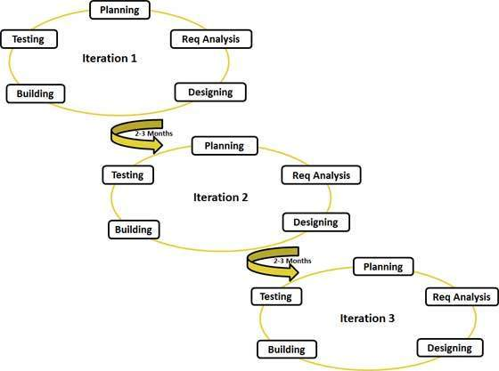

Figure .Agile model

1. In waterfall model once an application is in the testing stage, it is very difficult to go back and change something that was not well-thought out in the concept stage. No working software is produced until late during the life cycle. High amounts of risk and uncertainty. Not a good model for complex and object-oriented projects. Poor model for long and ongoing projects. Not suitable for this project as requirements are at a moderate to high risk of changing.
2. In Iterative model each phase of an iteration is rigid with no overlaps. Costly system architecture or design issues may arise because not all requirements are gathered up front for the entire lifecycle
3. Spiral model be a costly model to use. Risk analysis requires highly specific expertise. Project’s success is highly dependent on the risk analysis phase.
4. Incremental model requires a good planning designing. Problems might cause due to system architecture as such not all requirements collected up front for the entire software life cycle. Each iteration phase is rigid and does not overlap each other. Rectifying a problem in one unit requires correction in all the units and consumes a lot of time
5. Agile model provides customer satisfaction by rapid continuous delivery of useful software. People and interactions are emphasized rather than process and tools. Customers, developers and testers can constantly interact with each other. Working software is delivered frequently. The requirements of this project may change and cannot be specified earlier. Even late changes in requirements are welcomed. As our project fits well according to Agile model .Thus we decided to implement Agile model.

**4.6 Important Modules**

**4.6.1 Module 1**

**Input System:**

Primary Input to our system will be the current sensor which will be connected to microcontroller in series with Energy Meter. It will give the analog value for the total electricity passing through it. Microcontroller will read the total consumption unit of the current sensor.

**Input Processing System:**

Arduino will be used as data processing unit. The program written in embedded C++ for microcontroller will take the value from current sensor and upload it to the corresponding web interface with data entry in corresponding database.

**Circuit Breaker Activation:**

The microcontroller connected to a relay will control the relay according to the program written in it. When the account balance is over, the circuit breaker will get activated and it will cut the electricity supply. Once the recharge is done, the circuit breaker gets off, which completes the circuit and the electricity supply starts again.

**4.6.2 Module 2:**

A GUI will be designed in PHP for user as well as administrator. The web page will be authenticated. The consumed units recorded by microcontroller will be uploaded to the web interface and at the same time sent to the database. The database will be created in MySQL which will have the users’ information, the consumed electricity unit and the recharge logs. The user GUI will contain buttons to view the electricity rates, units consumed, account balance and to recharge the account. Calculation formula will be coded in administrator’s page source. Calculation will be done whenever user requests for it or when a new recharge is done. The taxes and electricity rates will be applied to the calculated amount and final amount will be updated.

**4.6.3 Module 3:**

The results of calculation as well as current status of the account can be viewed using the web page. An android application will also be provided only for the user for a quick access. The program will be written to send notification to user before the balance is about to reach the threshold value as well as when the account balance is over.

**4.7 Implementation and Coding:**

**4.7.1 Technologies used:**

**1. Arduino:**

The Arduino is an open source electronics prototyping platform by Google, based on flexible, easy to use hardware and software. Arduino is best known for its hardware, but you also need software to program that hardware. The software is free, open source and cross platform. Arduino can sense the environment by receiving input from variety of sensors and can affect its surroundings by controlling lights, motors, and others actuators. The microcontroller on the Arduino is from ATMEL Corporation and is programmed by Arduino programming language (based on WIRING) and Arduino development environment (based on PROCESSING).

**2. Arduino UNO**

**Arduino** is an open-source hardware and software company, project and user community that designs and manufactures single-board microcontrollers and microcontroller kits for building digital devices. Its products are licensed under the GNU Lesser General Public License (LGPL) or the GNU General Public License (GPL), permitting the manufacture of Arduino boards and software distribution by anyone. Arduino boards are available commercially in preassembled form or as do-it-yourself (DIY) kits.

* + 1. **Languages used:**

. PHP + HTML:

For the design of the webpage and also for the interfacing of the microcontroller and webpage PHP and HTML language is used. PHP is a server-side scripting language designed primarily for web development but is also used as a general-purpose programming language code may be embedded into HTML code, or it can be used in combination with various web template systems, web frameworks.

**4.7.3 Programming tools used:**

1. Xampp Version 3.2.2
2. Arduino IDE 1.8.10

**4.7.4 Important classes:**

1. Running Statistics:

This class keeps track of variable’s statistics, over a specified window of time (a “running window”), up to the current time. It calculates variance and mean, as well as the derived values such as standard deviation(sigma) and coefficient of variation.

**4.8 Further work**

1. Write program in embedded C++ for microcontroller to take the value from current transformer and upload it to the corresponding web interface with data entry in corresponding database.

2. Connect the microcontroller to GSM and GPRS. Connect microcontroller to a relay and write code to control the relay. Write code to send message when the balance is about to finish or reaches threshold value and when the account balance is over, the circuit breaker will get activated and it will cut the electricity supply. Once the recharge is done, the circuit breaker completes the circuit and the electricity supply starts again.

3. Create webpage in PHP, HTML, Java script for the user to get quick access

4. Design GUI for user as well as administrator. The web page will be authenticated. The consumed units recorded by microcontroller will be uploaded to the web interface and at the same time sent to the database. The user GUI will contain buttons to view the electricity rates, units consumed, account balance and to recharge the account. Calculation formula will be coded in administrator’s page source. Calculation will be done whenever user requests for it or when a new recharge is done. The taxes and electricity rates will be applied to the calculated amount and final amount will be updated.

5. Create Database MySQL which will have the users’ information, the consumed electricity unit and the recharge logs. The results of calculation as well as current status of the account can be viewed using the web page stored in database.

**CHAPTER 5- DETAILS OF DESIGNS,WORKING AND PROCESSES**

**5.1 Design**

**5.1.1 System Architecture Diagram**

The following is the system architecture that incorporates current sensor, Arduino UNO, Circuit breaker unit and Database for the need of prepaid paperless energy meter reading system and shows how the system will look like.

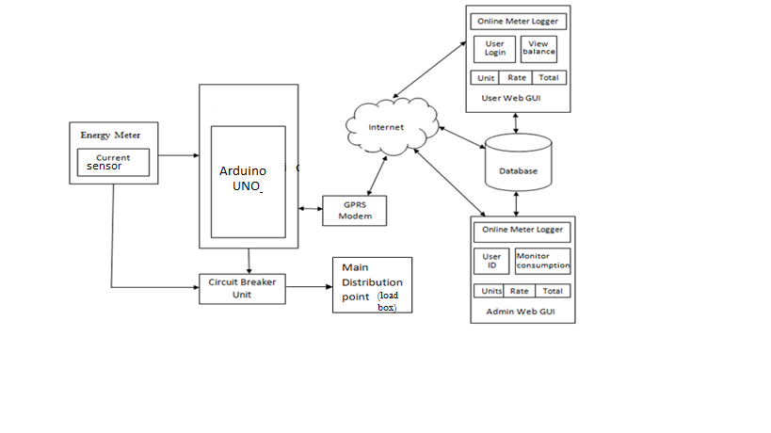

**Figure 2 .System Architecture**

In the above figure of system architecture, energy meter consists of current sensor which senses the amount of current passing through it. It is connected to the Arduino UNO as well as circuit breaker unit that is relay. Current sensor gives signal to the Arduino UNO which takes the reading from sensor and upload to the custom created webpage by using GPRS service. Circuit breaker unit cut of the power supply after getting signal from Arduino UNO. Database consists of records of all the users which are updated continuously through GPRS service. The user can check the status of consumption of energy through android application as well as user web GUI.

**5.2 DFD**

**5.2.1 DFD Level 0**

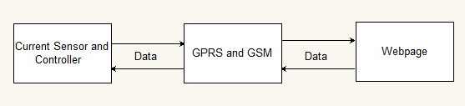

* + 1. **DFD Level 1**

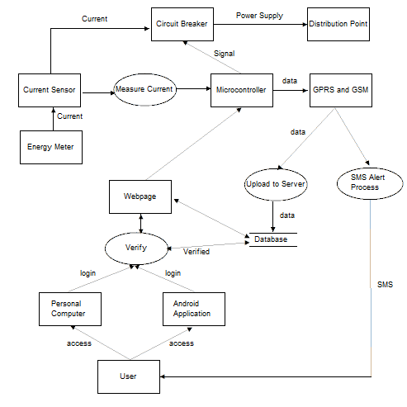

* 1. **Sequence Diagram:**

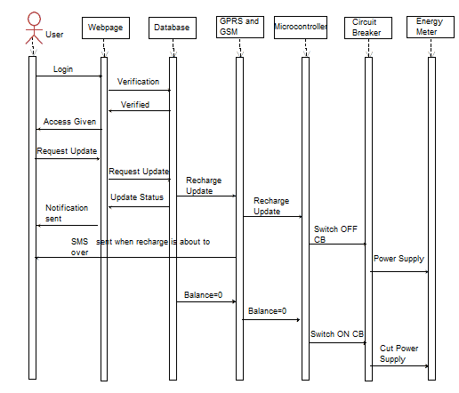

Figure: sequence diagram

* 1. **Circuit diagram**

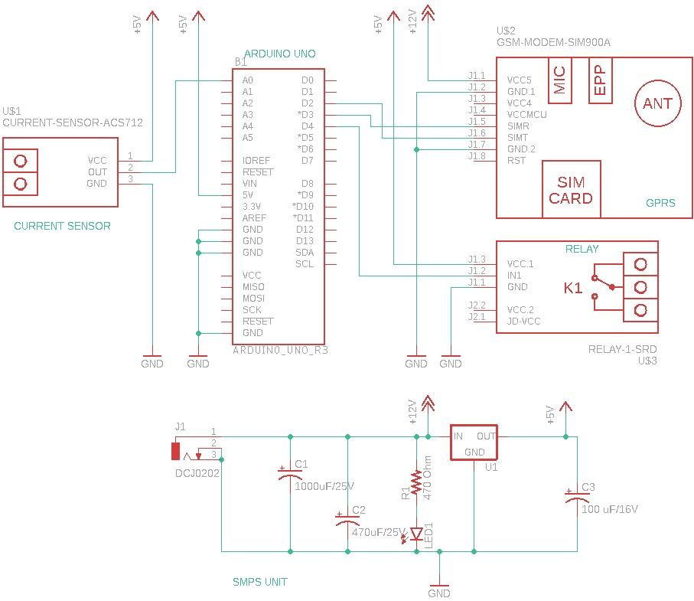

* 1. **Source code:**
* **Program to take values from sensor**

#include <Filters.h> // (Real Time Digital Signal Processing Library)

RunningStatitics is a class of <filters.h>

float testFrequency = 50; // test signal frequency (Hz)

float windowLength = 20.0/testFrequency; // how long to average the signal, for statistist

int sensorValue = 0;

float intercept = -0.03; // to be adjusted based on calibration testing

float slope = 0.0200; // to be adjusted based on calibration testing

float current_amps; // estimated actual current in amps

//double total = 0.00001;

unsigned long printPeriod = 1000; // in milliseconds

// Track time in milliseconds since last reading

unsigned long previousMillis = 0;

void setup() {

Serial.begin( 9600 ); // start the serial port

pinMode(4,OUTPUT);

pinMode (A0,INPUT);

digitalWrite(4,LOW);

}

void loop() {

RunningStatistics inputStats; // create statistics to look at the raw test signal

inputStats.setWindowSecs( windowLength ); setWindowsSec is property of <filters.h>

inputstats.input is used to take sensor value as input on sensor

while( true ) {

sensorValue = analogRead(A0); // read the analog in value:

inputStats.input(sensorValue); // log to Stats function

Object is created of the same by the name inputstat

if((unsigned long)(millis() - previousMillis) >= printPeriod) {

printperiod is used to track time in millliseconds to consume more units.

previousMillis = millis(); // update time

// display current values to the screen

millis() is function of <filters.h> used to count every second of the arduino

previousMillisecond is the last elasped value

Serial.print( "\n" );

// output sigma or variation values associated with the inputValue itself

Serial.print( "\tsigma: " ); Serial.print( inputStats.sigma() );

// convert signal sigma value to current in amps

current_amps = intercept + slope * inputStats.sigma(); sigma() is a function of arduino

Serial.print( "\tamps: " );

Serial.print( abs(current_amps-0.01));

abs() is mathematical function to find absolute value of current in ampere

Serial.print( "\tWatt: " );

Serial.print( 230*(current_amps));

//total= total+(230*(current_amps)/3600);

//Serial.print( "\tWattHour: " ); Serial.print( total,5);

}

}

}

* **Program to send and receive messages through GSM**

#include <SoftwareSerial.h>

SoftwareSerial mySerial(2, 3); // 2 = Rx 3 = Tx

void setup()

{

mySerial.begin(9600); // Setting the baud rate of Serial2 Module

Serial.begin(9600); // Setting the baud rate of Serial Monitor (Arduino)

//delay(100);

}

void loop()

{

if (Serial.available()>0) // arduino serial port

switch(Serial.read())

{

case 's':

MessageSendKaro();

break;

case 'r':

MessageAayaHai();

break;

}

if (mySerial.available()>0) // Serial2 serial port

Serial.write(mySerial.read());

}

void MessageSendKaro()

{

mySerial.println("AT+CMGF=1"); //Sets the Serial2 Module in Text Mode

delay(1000); // Delay of 1000 milli seconds or 1 second

mySerial.println("AT+CMGS=\"+917558280906\"\r"); // Replace x with mobile number

delay(1000);

mySerial.println("hi....hello.....!!!!"); // The SMS text you want to send

delay(100);

mySerial.println((char)26); // ASCII code of CTRL+Z

delay(1000);

}

void MessageAayaHai()

{

mySerial.println("AT+CNMI=2,2,0,0,0"); // AT Command to receive a live SMS

delay(1000);

}

**CHAPTER 6: RESULTS AND APPLICATIONS**

**6.1 APPLICATION**

* Settlement and billing
* State estimation of power distribution networks
* Monitoring of power quality and reliability
* Customer service by DSO, RESC and ESCO
* Load analysis, modelling and forecasting
* Improving competition and efficiency in energy markets
* Demand response for electricity market and for network operation support, peak load limitation
* Ancillary services such as frequency controlled reserve, voltage and reactive power control
* Services for monitoring and improving energy efficiency of end use and dispersed generation, Customer information feedback
* Providing information for authorities and researchers
* End use energy management.

**6.2 RESULTS**

**Screenshot:**

1. **SMS sending and receiving through gsm and arduino**

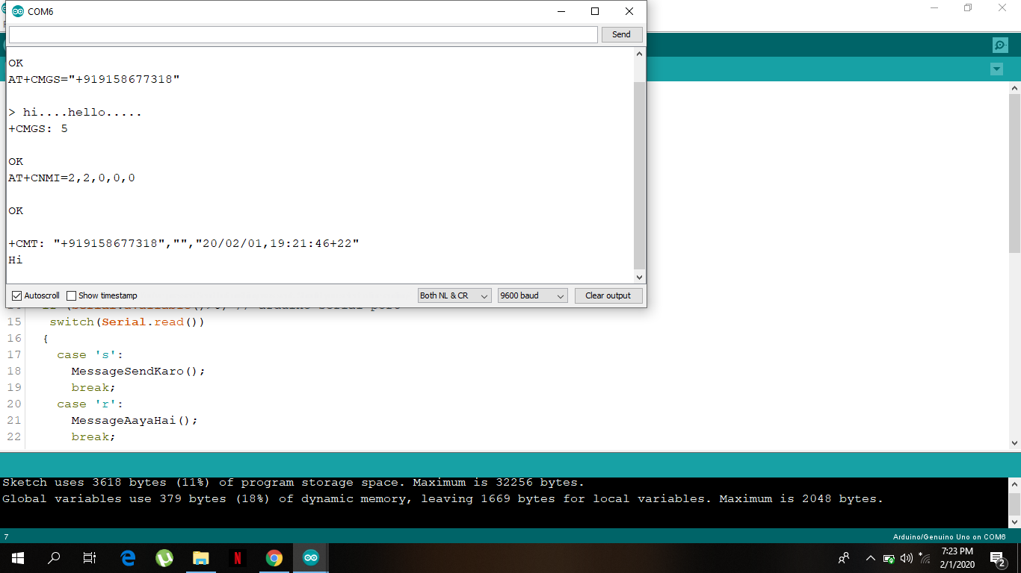

1. **Calibrating sensor by changing values of intercept and slope**

**RESULT: Sensed values of bulb of 5W and laptop of 64W**

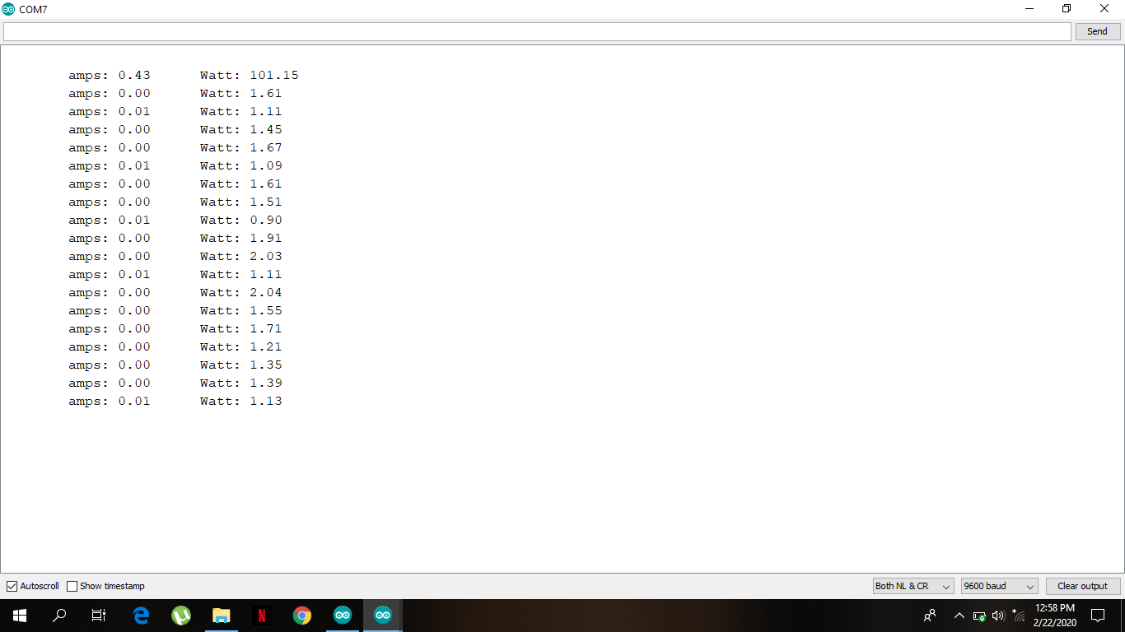

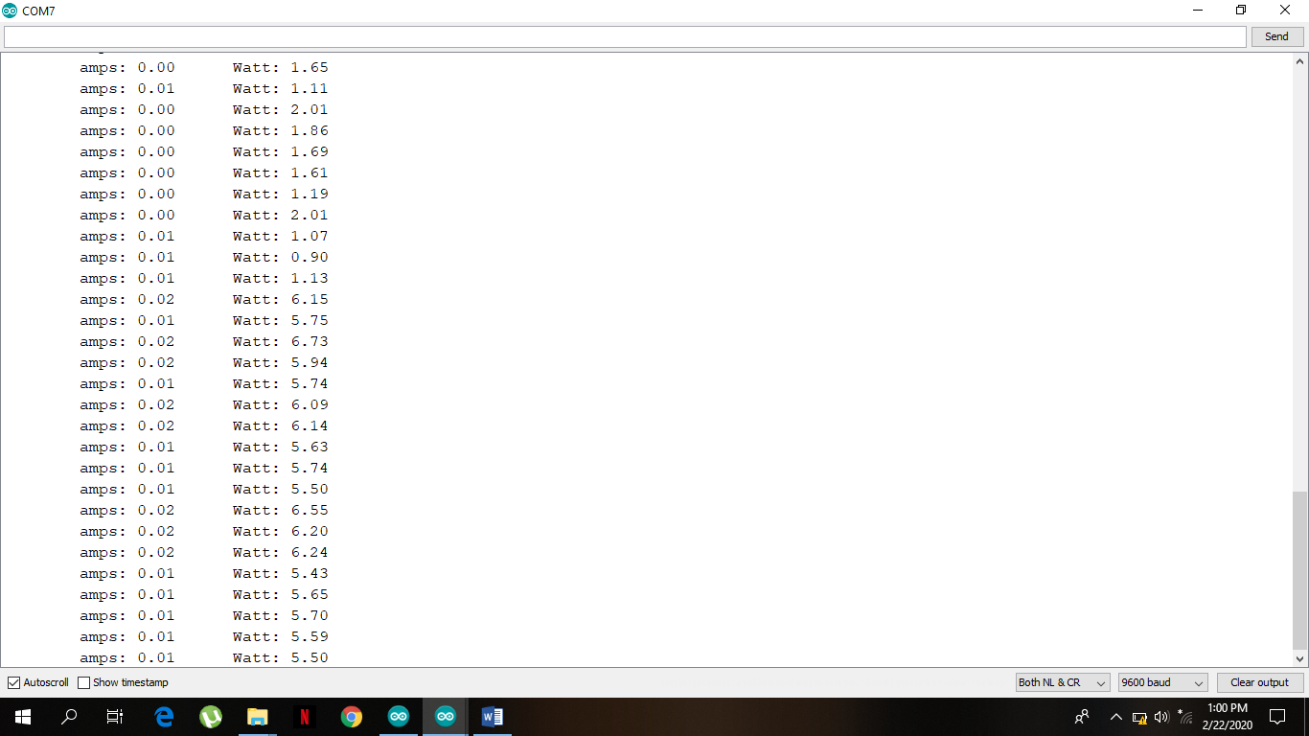

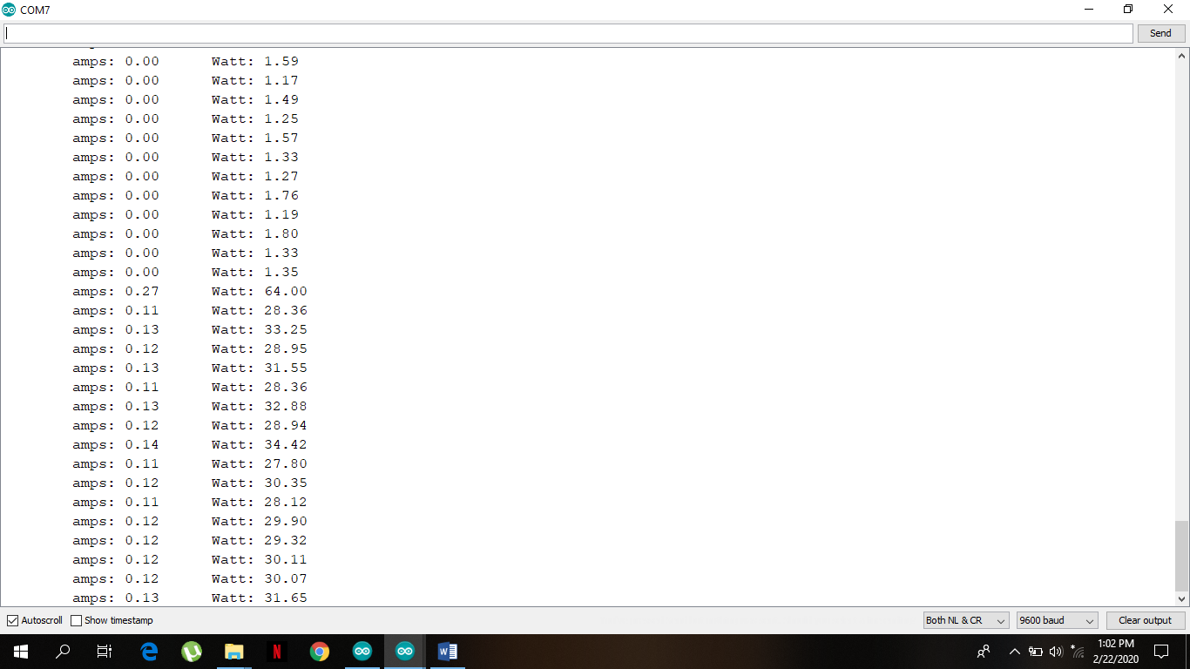

1. **Website for billing system**

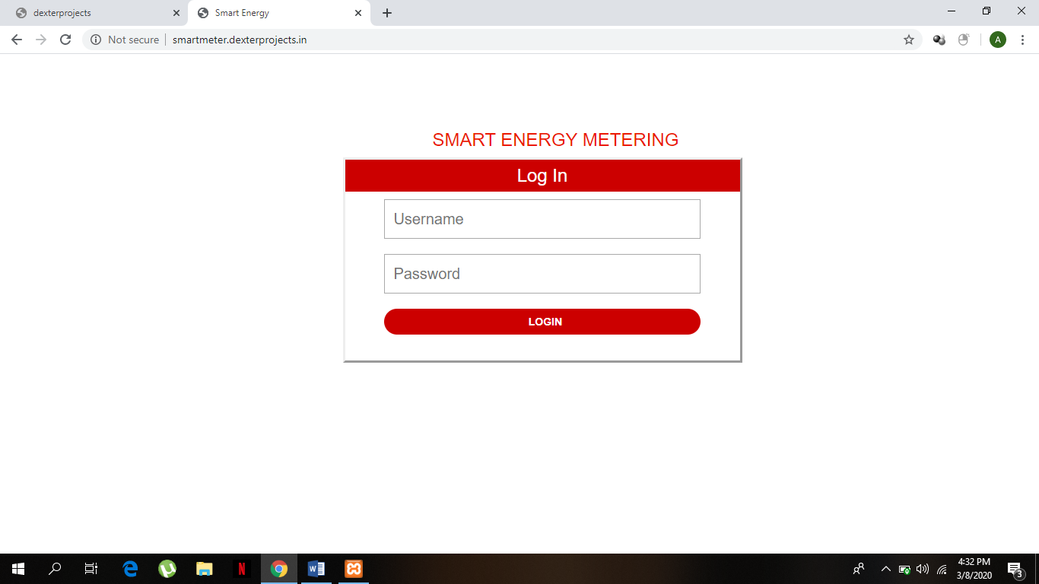

1. **Login using appropriate username and password**

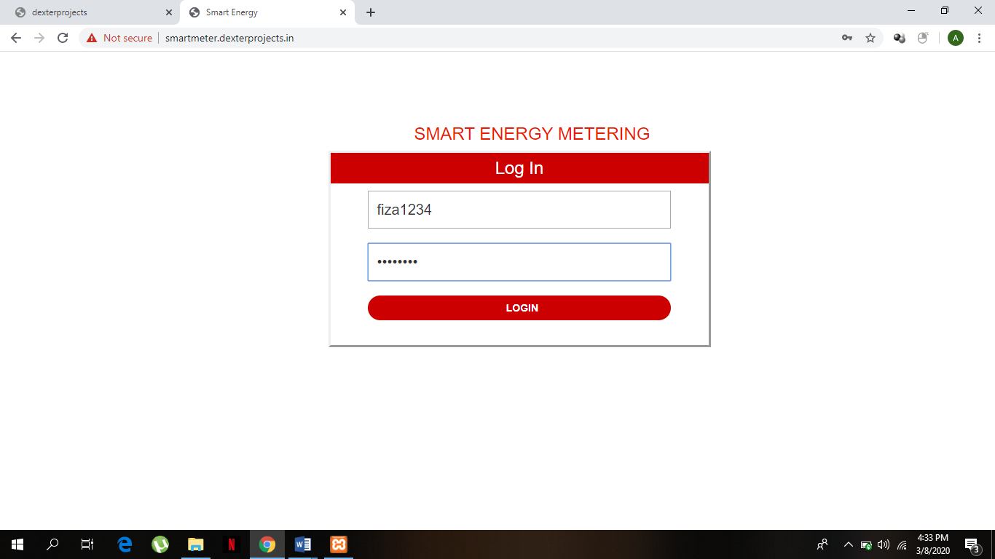

1. **Web page to check the user details, units consumed , units left and balanced recharge.**

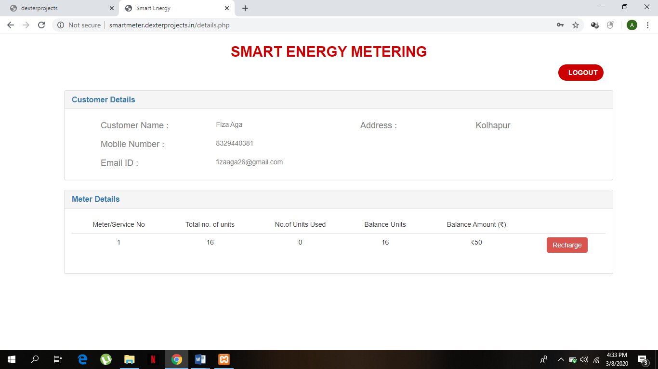

1. **Payement module to enter the details and recharge the system.**

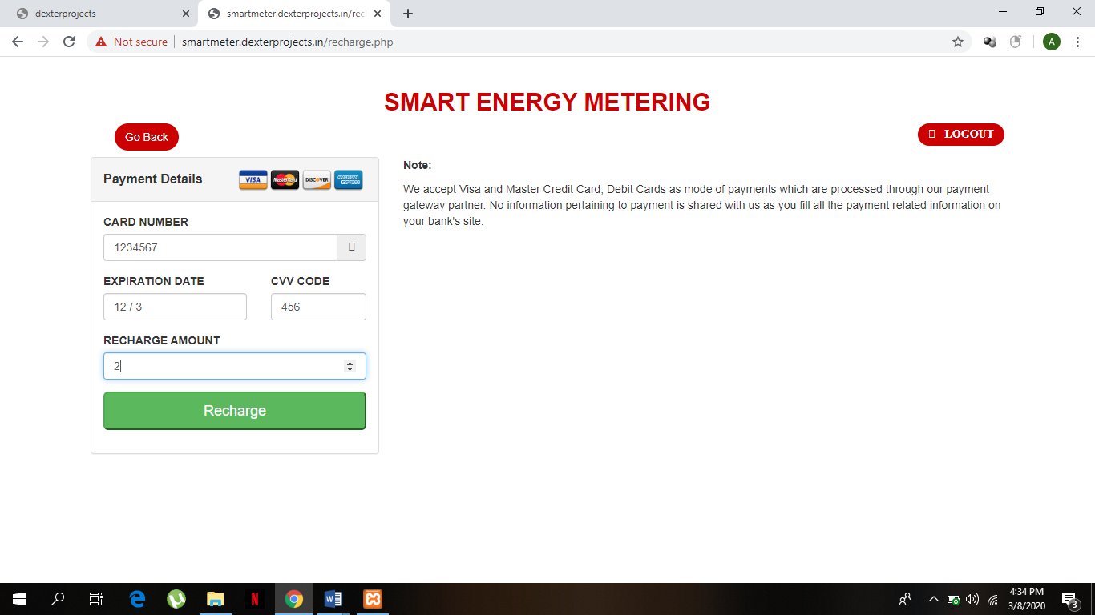

7.**Message received by the user**

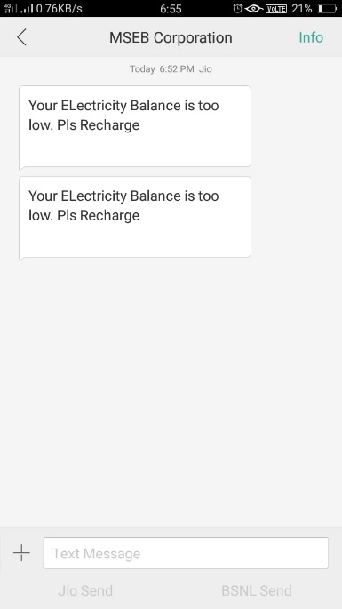

* 1. **Testing methods**

**Software testing methodologies** are the various strategies or approaches used to test an application to ensure it behaves and looks as expected. These encompass everything from front to back-end testing, including unit and system testing.

 These testing methods are usually conducted in order and include:

* Unit testing
* Integration testing
* System testing
* Acceptance testing

Non-functional testing methods incorporate all test types focused on the operational aspects of a piece of software. These include:

* Performance testing
* Security testing
* Usability testing
* Compatibility testing

**CHAPTER 7- CONCLUSIONS AND FUTURE SCOPE**

**7.1 Conclusion:**

The proposed Smart Metering System is capable of monitoring various parameters of electrical energy like Voltage, Power Factor, Current, energy consumption in kWh etc., and the consumer can take suitable precautions to safe guard the electrical appliances. This makes the consumer an active part of Energy Management. The consumer can also monitor the load during peak hours. If the amount of load shifted to normal hours there by the peak demand will go down and hence power generation during peak hour can be reduced, this brings the production cost down. Since, the consumers get benefited for limiting the consumption during peak hours, they become vigilant in managing electricity consumption. Hence, the designed Smart metering system is useful to both utility Provider and consumers.

**7.2 Future scope:**

Smart energy meter is an important device to manage electricity usage. It collects information of power usage from the appliances and communicates this information to the Utility center. The utility center can plan or estimate for the necessary load accordingly.

If generation capacity is less then it informs owner about this and requests for cooperation. Based on generation capacity and load usage there may be also per-hour-tariff system available.

According to the International Energy Agency, world electricity demand is projected to increase by nearly 80% over the years 2012 to 2040. Modernization, expansion and decentralization of the electricity infrastructure for improved robustness and resiliency is a clear imperative, with the World Economic Forum recently calling for transformational investments exceeding $7.6 trillion over the next 25 years.

**CHAPTER 8: REFERNCES AND BIBLOGRAPHY**

**8.1 Websites:**

1. [www.arduino.cc](http://www.arduino.cc)
2. [www.sparkfun.com](http://www.sparkfun.com)
3. [www.circuitdigest.com](http://www.circuitdigest.com)
4. [**www.javatpoint/php.com**](http://www.javatpoint/php.com)
5. <https://www.youtsssube.com/playlist?list=PL442FA2C127377F07>

**8.2 Reference paper:**

1. Automatic Meter Reading and Theft Control System by Using GSM *- P. Rakesh Malhotra et al. / International Journal of Engineering and Technology (IJET), Vol 5 No 2 Apr-May 2013, ISSN : 0975-4024*
2. Live Energy Meter Reading and Billing System through GPRS – *International Journal of Engineering Research & Technology (IJERT), Vol. 4 Issue 05, May-2015, ISSN: 2278-0181*
3. V.Preethi, G. Harish,” Design And Implementation of Smart Energy Meter”, Inventive Computation Technologies (ICICT), 26-27 Aug. 2016